Using this Template

The following template can be used to help your organization develop a written Electrical Safety Program. This template cannot be used as is – you must customize the template to meet the needs of your organization and your state laws. We have made this template easy for you to customize by adding visual prompts that identify where your input is needed. These are identified by yellow highlighted, red text in the template. You may also change any of the text in the template to meet your organization’s needs – for example, department names, job titles and listed responsibilities and procedures.

Example:

<COMPANY NAME>
Electrical Safety Program

becomes
XYZ Company
Electrical Safety Program

To remove the colored highlighting from your text, left click and drag your mouse over the yellow text and click on the highlighter button from the Font menu. To change the font color to black, select the text and click on the font color button.

To aid you in understanding the need to customize your program, several “Check Your Understanding” text boxes are also included throughout the template. After reading the information in the text box and adding the required information into the template, you may simply right click on the cross arrow box and select “cut.”
Disclaimer. This sample safety program template cannot be used as is. You must customize the template to meet the needs of your organization. EMC does not guarantee that this template is or can be relied on for compliance with any law or regulation, assurance against preventable losses, or freedom from legal liability. We make no representations or warranties of any kind whatsoever, either express or implied, in connection with the use of this template. EMC will not be liable for your use of the template as customized by you. All safety programs and policies, including this template and the information you supply to complete it, should be reviewed by your legal counsel and/or risk management staff.

<COMPANY NAME>
Electrical Safety Program

Check Your Understanding. Do you need an electrical safety program? If your employees perform maintenance on electric equipment or machines, or simply work with electrical tools, extension cords or are exposed to electrical hazards, the answer is yes. This program is designed to protect employees exposed to hazards such as electric shock, electrocution, fires and explosions.

Revision History

Revision 1 – <Month> <Year>

Purpose and Scope

<Company Name> is committed to providing a safe and healthy work environment and to protecting employees from injury or death caused by uncontrolled electrical hazards in the workplace. The purpose of <Company Name’s> Electrical Safety Program is to establish work policies, practices and procedures to train employees in basic electrical hazard recognition and safe work practices. This program applies to qualified and non-qualified employees who are exposed to electricity as part of their job.

Program Responsibilities

Management. Along with providing financial and leadership support, the management of <Company Name> will assist the Program Administrator, supervisors and employees with complying with this policy.

Program Administrator. The Program Administrator is responsible for:

- Identifying work tasks that need to be performed by a qualified employee
- Conducting electrical safety inspections
- Correcting electrical safety hazards as soon as possible
- Ensuring all new electrical equipment and components comply with this program
- Reviewing this program annually and revising if necessary
- Maintaining a list of all qualified employees (Appendix E)
- Conducting training for employees

Supervisors. Supervisors are responsible for:

- Conducting periodic work inspections using the form in Appendix B
- Ensuring employees are provided with and use the appropriate PPE
- Ensuring employees comply with all aspects of the Electrical Safety Program
- Testing electrical hand tools every three months with an ohmmeter

Employees. An employee will only work on electrical equipment if he/she is a qualified worker, meaning he/she has been trained and authorized to perform work on deenergized electrical equipment and components. Employees are responsible for:
- Wearing the appropriate PPE when working with or around electrical equipment
- Reporting electrical safety hazards to their supervisor of the Program Administrator
- Following the safe work practices outlined in this program
- Visually inspecting electrical equipment, tools and cords before each use
- Completing all required training

Check Your Understanding. Many electrical injuries occur when workers attempt to work on electrical equipment for which they are not qualified. Who is a qualified person? A qualified person is one who has received training in, and has demonstrated skills and knowledge in, the safe operation of electrical equipment and the hazards involved. The Occupational Safety and Health Administration (OSHA) allows only qualified persons to work on or around energized circuits or equipment. A worker can be qualified to perform a specific task on a piece of electrical equipment, but unqualified to perform the same task on a different piece of equipment. For the purpose of this program, a qualified person is one who performs maintenance on deenergized, locked and tagged out equipment or works with electrical tools as part of their job.
An unqualified person is one who has little or no training in electrical work. Unqualified workers may not perform work on or be exposed to energized parts. An unqualified worker still must be familiar with electrical-related hazards and how to report an uncontrolled hazard.

Work Practices
All electrical equipment will have the manufacturer’s name, trademark or other descriptive marking which identifies the organization responsible for the product. The equipment will also have its operating voltage, current, wattage or other rating clearly marked on it.
Qualified employees will use lockout/tagout procedures on all electrical equipment while completing maintenance work. Lockout/tagout procedures are found in <Company Name’s> Lockout/Tagout Program. If the equipment cannot be deenergized because it would introduce an additional or increased hazard, or it is infeasible due to the design or its operational limitations (i.e. emergency alarm systems), <Company Name> will hire a qualified electrical contractor to perform the work. No work will be performed on energized equipment by <Company Name> employees.

Check Your Understanding. If you are an electrical contractor who performs work on live electrical equipment, there are additional regulations that must be followed when completing this type of work. These regulations take into consideration the potential for arc flash and other additional safety hazards that exists when working on live electrical parts. These safety precautions are outside the scope of this program. For additional information on working on or around live parts, consult OSHA.

Extension Cords and Power Strips
Employees must be aware of the hazards associated with the misuse of extension cords and power strips. All power strips must be UL listed and used according to the manufacture’s guidelines.
Choosing an Appropriate Extension Cord. <Company Name> has a variety of extension cords available for employee use. Employees will select an extension cord that can handle the electricity requirement for any connected tools or equipment. All employees will adhere to the following guidelines when choosing an appropriate extension cord.
- Lights and fans (1-13 amperage rating). Employees may use a 25-100 foot long extension cord with 16 gauge wire, or a 150 foot cord with 14 gauge wire.
- Small electrical hand-held tools, such as drills and sanders (14-15 amperage rating). May use a 25-100 foot long extension cord with 14 gauge wire, or a 150 foot cord with 12-10 gauge wire.
- Large electrical tools such as shop vacuums, circular saws, table saw and space heaters (16-20 amperage rating). May use a 25-100 foot long extension cord with 12-10 gauge wire. Do not use an extension cord longer than 100 feet with large electrical tools.
* All extension cords used for construction or outdoor maintenance work will be equipped with, or connected to, a ground fault circuit interrupter (GFCI).
If an employee is unsure which size of extension cord he/she should use, contact a supervisor or the Program Administrator.
Check Your Understanding. You can usually find the gauge and amp ratings listed on the electrical device or in the instruction manual. The electricity rating for an electrical cord is usually listed on the cord itself.

Safe Work Practices for Extension Cords and Power Strips. The following safe work practices will be followed at all times by all employees when using an extension cord or power strip.
- No employee will plug in or unplug a power strip or extension cord with wet hands.
- Power strips will only be used in office settings.
- Grounding prongs will never be removed from the end of any extension cord or power strip. No strip or cord with a missing grounding prong shall be plugged into outlets.
- All extension cords and power strips will be inspected before use. If any defects are found, the cord or strip will be removed from service.
- All power strips and extension cords will be tested using an ohm meter every 3 months.
- If and when extension cords or power strips are used, they will not be:
  - Run through holes in walls, ceilings or floors
  - Run through doorways or windows without appropriate protection
  - Used in areas where vehicles, forklifts or other equipment could drive over the cord
  - Fastened with staples or hung in a way that could damage the insulation
  - Used for more than 30 days
If it is necessary to run an extension cord through a doorway (for example, work completed outdoors with no outlet), the cord will be protected using high contrast tape or coverings and will not be left out overnight. Employees must get approval from the Program Administrator before an extension cord can be used in this manner.

Repairing and Replacing Electrical Cords
If a cord is damaged, the following guidelines will be followed:
- All repairs will be completed by <equipment repair shop>.
- Electrical shrink wrap will be used to repair the cord. One shrink wrap repair can be used per cord. The cord will be replaced if a second repair is needed.
- The electrical shrink wrap will cover no more than 12 inches of the cord.
- After the repair, the cord must retain its original flexibility and integrity.
- If the inner insulation is damaged, the cord must be replaced.
- Damaged cords used in wet areas shall be immediately replaced.
Check Your Understanding. Never repair electrical cords or equipment unless you are qualified and authorized to do so. If you do not have a person on staff qualified and authorized to make a needed repair, have a qualified electrician make the repair.

Circuit Overload
To reduce the possibility of overloaded circuits, <Company Name’s> employees will only plug in one device per outlet. Employees will not use splitters, multi-plug adapters, etc. without direct permission from the Program Administrator. If you have a concern that a circuit may be overloaded, you are to contact your supervisor or the Program Administrator as soon as possible.
Tools
The following requirements shall be adhered to at all times:
- All electrical tools will be stored in a clean, dry place when not in use.
- Employees will not carry electrical tools by the cord or yank cords from the wall.
- If a tool is unintentionally deenergized due to a circuit breaker or GFCI, it must be removed from service until the cause of deenergization is discovered.
- All electrical tools will be tested using an ohm meter every 3 months.
- All tools will have grounding prongs. Any tool without a grounding prong will be removed from service.
- All electrical tools will be inspected before use. If any defects are found, the tool will be removed from service until it can be repaired or replaced.
- Fiberglass ladders will be used when working around or on electrical equipment or wires.
Guarding
All electrical systems must be guarded to prevent contact with live conductors. The following requirements will be adhered to at all times:
- All electrical distribution panels, breakers, disconnects, switches and junction boxes will be completely enclosed.
- Live parts to electrical equipment operating at 50 volts or more must be guarded to prevent contact and prevent damage.
- All electrical receptacles and cover plates will be kept intact and in good condition.
- All electrical panels will be easily accessible at all times and a minimum of three feet of clearance shall be maintained on all sides.
High Voltage Electrical Rooms and Closets
The following requirements for electrical rooms and closets shall be adhered to at all times:
- High voltage rooms and closets must be locked at all times.
- Only qualified employees are allowed into high voltage rooms and closets.
- No <Company Name> employee will open or remove covers or access panels of high voltage electrical distribution panels or transformers.
- Nothing will be stored in rooms or closets designated for electrical equipment.
- Safety signs which warn employees about any electrical hazards shall be displayed prominently on the door of the room or closet. (Appendix D)
Ground Fault Circuit Interrupters
Ground fault circuit interrupters (GFCIs) protect <Company Name’s> employees who use electrically-powered tools and equipment from electrical shocks, especially when working in wet environments. GFCIs are required for electrically-powered equipment and tools in the following conditions:
- When used at locations where employees are likely to contact water or conductive liquids, such as outdoors, bathrooms, kitchens or any other area with potential exposure to water
- When used at construction or renovation sites
- When used for portable lighting in wet or other conductive locations (such as inside boilers or tanks)

Check Your Understanding. A GFCI monitors the amount of current flowing from the hot wire to the neutral wire. If the amount of current is not even, the device automatically shuts off the electric power in as little as 1/40 of a second to prevent electrocution. GFCIs are easily recognized by the test and reset buttons built into the devices. The GFCI can be located on the extension cord, outlet or the circuit breaker. A GFCI is required in outlets that are installed around sinks or any other areas where water may be present.

Working near Power Lines
Both overhead and underground power lines present electrical hazards. The following procedures shall be adhered to when working near power lines.
- Remain at least 10 feet away from overhead power lines.
- If the voltage is greater than 50,000 volts, add 4 more inches of safe distance for each 10,000 volts beyond 50,000.
- When working around high voltage lines, ground all equipment that may become energized.
- Call <State’s> One Call Center <555-555-5555> 48 hours before any digging. Once underground power lines have been identified, add an additional 18 inch clearance on either side of the marking or flag. Do not dig in this clearance area. If it is required to dig within the clearance area <Company Name> will use an outside contractor to perform the work.
Additional Safety Precautions
The following additional safety precautions shall be adhered to at all times.
- If a circuit breaker trips or blows a fuse more than once, it shall be investigated and corrected by a qualified employee or contractor before being cleared for continued use.
- All areas with electrical equipment shall be properly illuminated.
- Housekeeping duties will not be performed in an area if there is a possibility of contact with an electrical hazard unless there are protective shields, barriers or if insulated materials are used to protect the employee.
- Safety signs that warn employees about any electrical hazards shall be displayed prominently when a hazard is present. (Appendix C)
Personal Protective Equipment (PPE)
Employees working in areas where electrical hazards are present will be provided with and shall use PPE that is designed for the specific part of the body to be protected and for the work being performed. Employees are required to adhere to the following procedures for PPE use:
- All PPE must be inspected prior to each day’s use and immediately following any incident.
- Non-conductive head protection will be worn if there is danger of electrical burns or shock from contact with electricity.
- When working on electrical equipment or wiring, employees will:
  - Not wear conductive articles of clothing or jewelry
  - Wear non-melting clothing such as cotton
  - Wear electrical-rated boots
  - Wear non-conductive gloves
Employee Training
Qualified Workers. At a minimum, qualified workers must be trained on the following:
- The hazards associated with electrical equipment
- Electrical safety practices and procedures (lockout/tagout) for doing deenergized work
- Safe work practices that must be followed when working around or with electrical tools or equipment
- How to distinguish exposed live parts from other parts of electrical equipment
- How to properly inspect and use the appropriate PPE
- The location of the electrical breaker panels and fuse boxes
Check Your Understanding. Need help with training? EMC has an online training course designed to cover general electrical safety awareness training. This training is free to all commercial policyholders.
Unqualified Workers. Unqualified workers will receive general electrical safety awareness training on how to recognize, evaluate and avoid electrical hazards and training on all <Company Name’s> electrical safety practices.
Training will occur before an employee begins work in a new area and when an employee does not comply with safe work practices. Retraining will occur every <3 years>. Training will be documented in Appendix A.
Periodic Program Review
The Program Administrator will review the Electrical Safety Program and procedures annually. The review will be documented on the form located in Appendix F.

Appendix A—Electrical Safety Program Training Record
The following individuals received training on <Company Names’> Electrical Safety Program.
Print Name | Sign Name
The undersigned conducted training in accordance with <Company Name’s> Electrical Safety Program.

Print Instructor’s Name
Instructor’s Signature
Instructor’s Title
Date of Training
Appendix B – Electrical Hazards Inspection
Supervisors at <Company Name> will use this form to periodically inspect their employees’ work practices. Any issues found during these inspections shall be addressed immediately.
Is lockout/tagout used before performing any maintenance on electrical equipment? | Yes | No | N/A
Have all employees received training and has it been documented? | Yes | No | N/A
Do all cords have the grounding prong? | Yes | No | N/A
Are tools being stored in a clean, dry place? | Yes | No | N/A
Are employees using and carrying tools properly? | Yes | No | N/A
Are insulated tools used? | Yes | No | N/A
Do all electrical tools have a grounding prong? | Yes | No | N/A
Are tools and power cords inspected prior to use? | Yes | No | N/A
Is the correct extension cord used? | Yes | No | N/A
Do extension cords remain in use for less than 30 days? | Yes | No | N/A
Are all extension cords and equipment cords run or protected so as to prevent damage to the cord’s insulation? | Yes | No | N/A
Is the area around electrical panels and boxes kept clear? | Yes | No | N/A
Are all electrical receptacles and cover plates kept in good condition? | Yes | No | N/A
Are areas with electrical equipment properly illuminated? | Yes | No | N/A
Are all electrical control devices properly labeled? | Yes | No | N/A
Are there safety signs warning employees about electrical hazards? | Yes | No | N/A
Are employees wearing proper clothing? (Non-conductive, no jewelry, etc.) | Yes | No | N/A
Are GFCIs used in wet locations? | Yes | No | N/A
Are all electrical distribution panels, breakers, disconnects, switches and junction boxes completely enclosed? | Yes | No | N/A
Are all live parts of electrical equipment operating at 50 volts or more guarded to prevent contact? | Yes | No | N/A
Are fiberglass ladders used when working near electrical hazards? | Yes | No | N/A
Are safe work distances maintained when working around power lines? | Yes | No | N/A
Is the One Call Center called at least 48 hours before any digging? | Yes | No | N/A
Is an 18 inch clearance maintained on either side of paint or flags indicating underground power lines? | Yes | No | N/A
What was done to address issues?

Supervisor Name:
Supervisor Signature:
Date:

Appendix C– Electrical Hazard Sign One
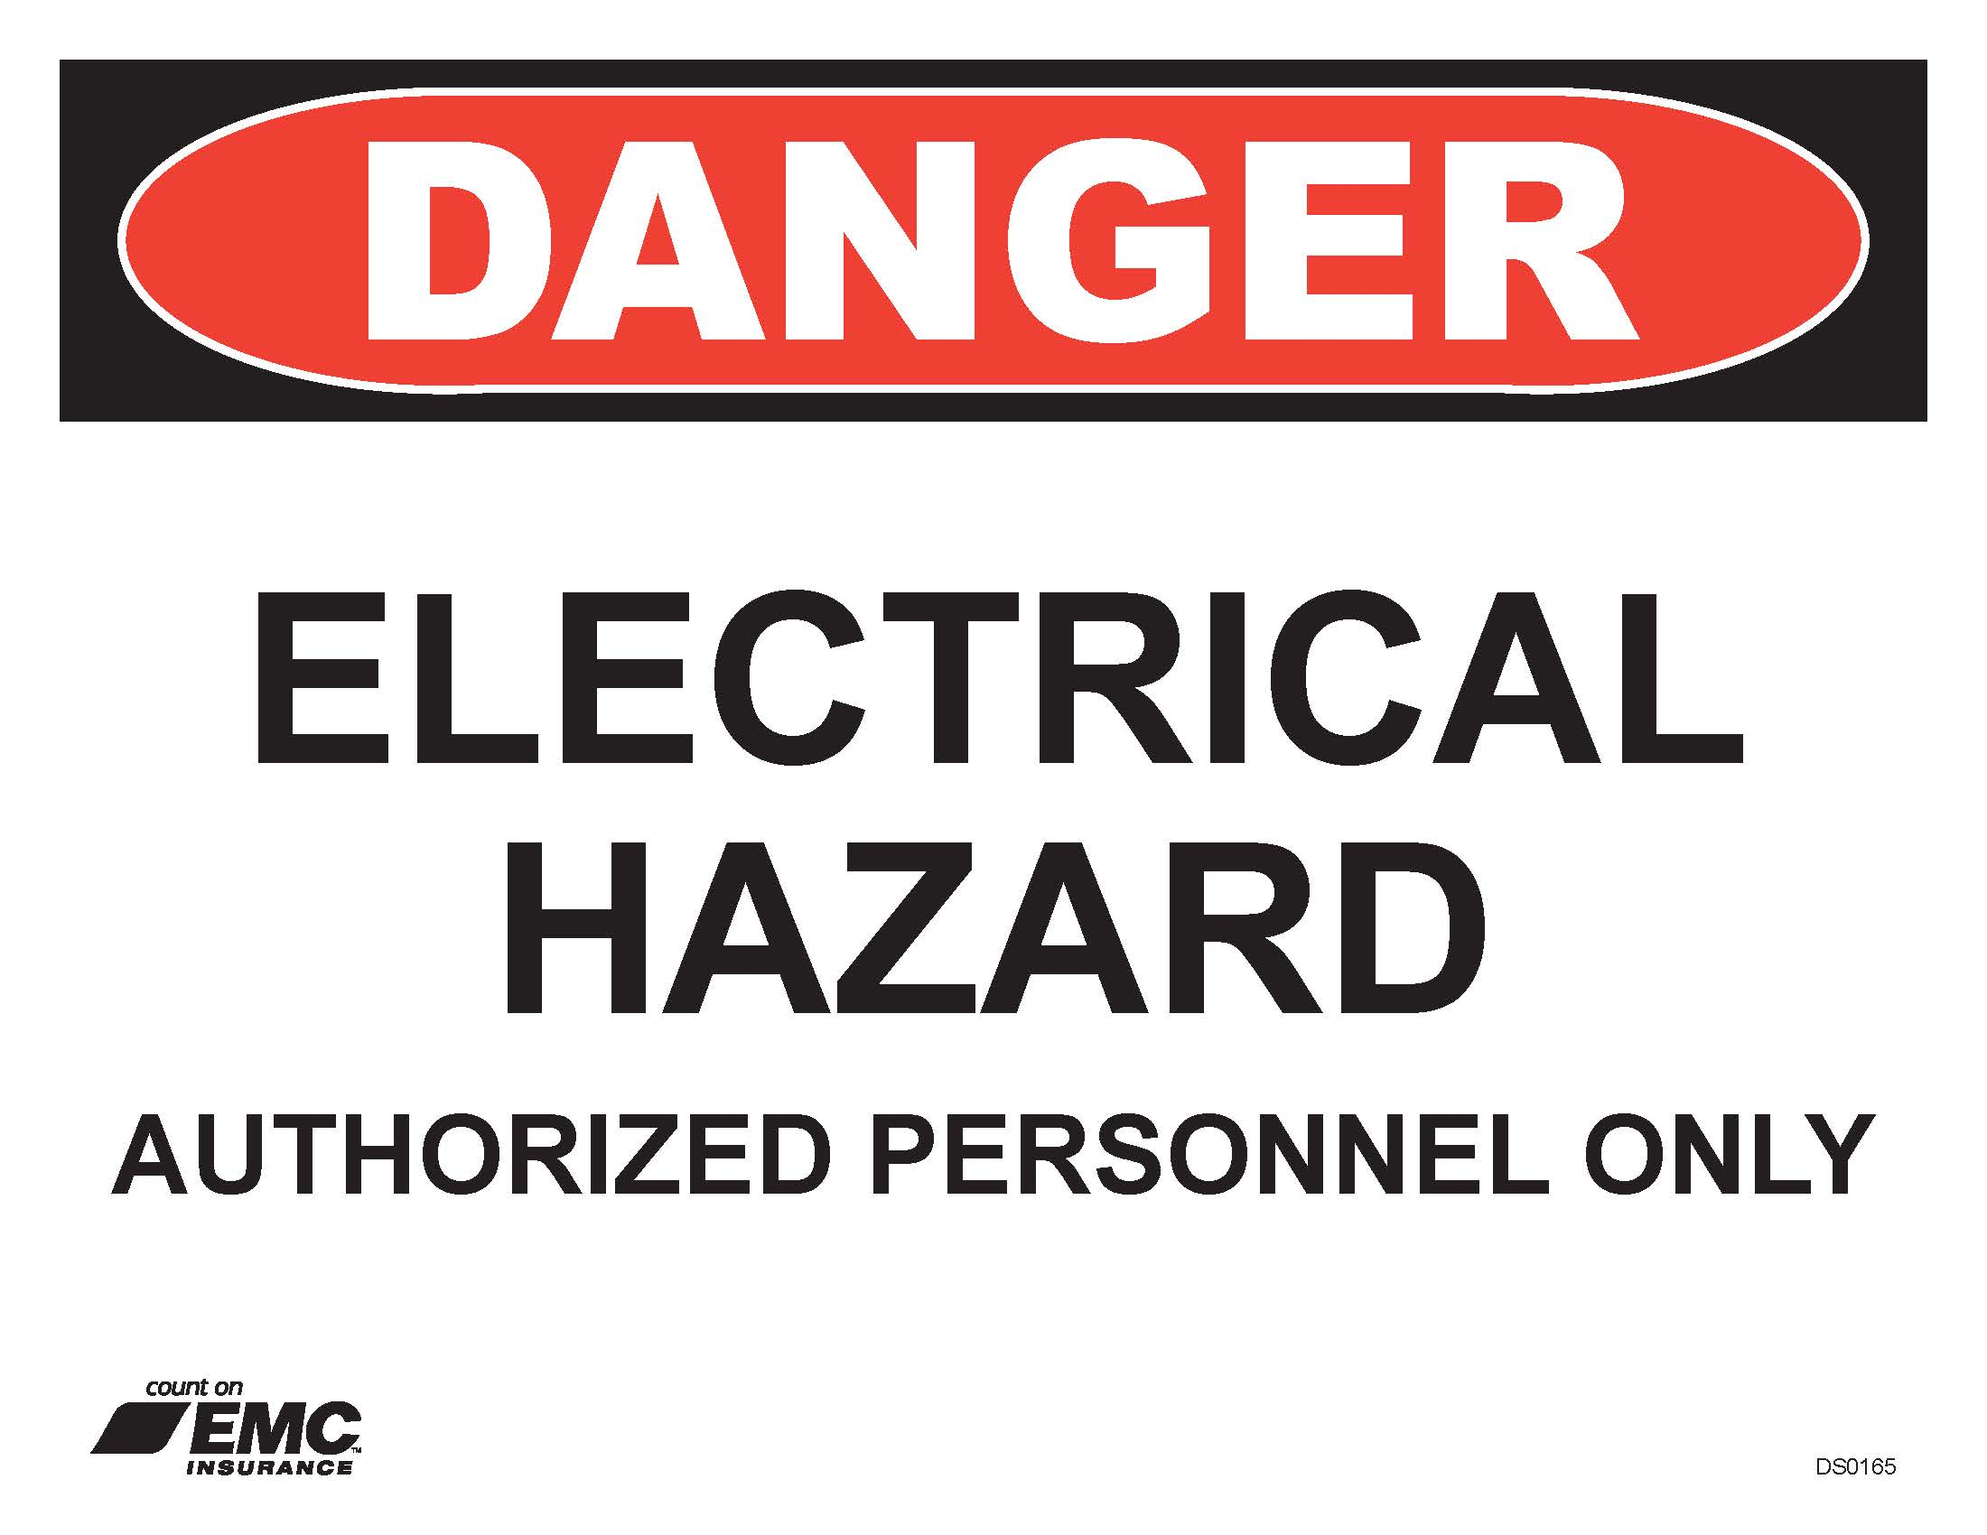
Appendix D – Electrical Hazard Sign Two
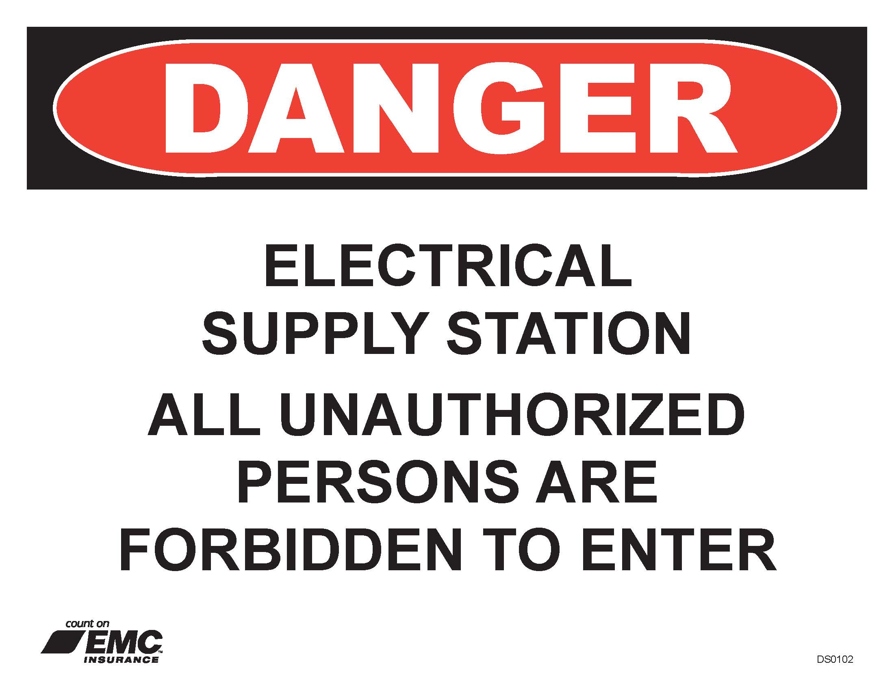
Appendix E – List of Qualified Employees
Name of Qualified Employee | Date of Qualification

Appendix F – Annual Evaluation Report
Date of Evaluation: | Evaluated By (list all present):
Written Program Reviewed: Yes No
Comments on Written Program:
The following specific procedures have been reviewed:
The following specific procedures were modified:
The following specific procedures were added:
A review of the accident reports and injury and illness reports were made: Yes No
The following additional expense(s) resulted from failure to use correct electrical safety procedures:
Comments:

